1. After which step we finished building the hardware platform for the embedded system?

Step 3-1-2: select **Create HDL Wrapper…** to generate the top-level VHDL model.

1. Briefly describe the major components in the hardware platform.

PS: processing system, with the following hardware components enabled: UART, one ARM Cortex A9, DDR controller.

1. What is the top-level description file for hardware platform? Copy the contents in this file that support the answer you provide in the previous question.

The top-level design file for hardware platform is system.hdf (hardware description file).

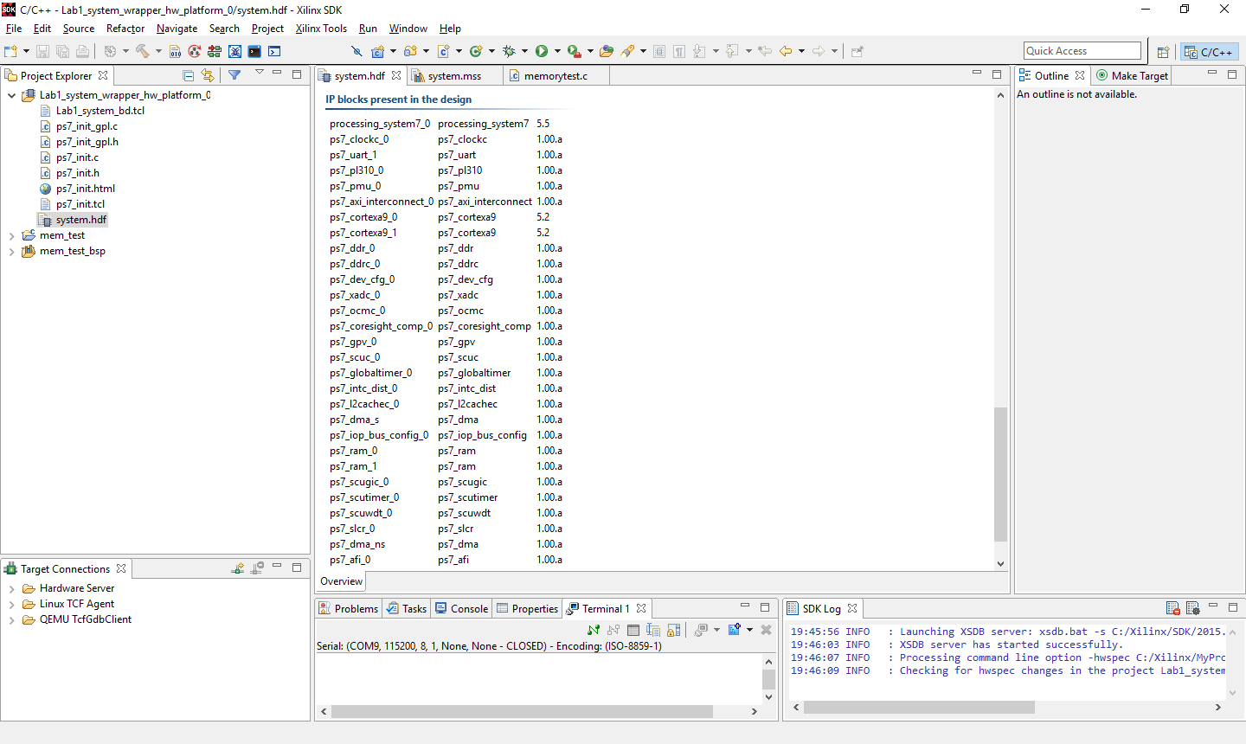

1. What does a bit stream file do? Is there a bit stream file generated for the hardware platform we built in this lab?

The bitstream (.bit) is the file that is used to configure the programmable logic (FPGA) of the Zynq-7000 AP device. No bit stream file is generated as we did not create any hardware design for PL in Lab 1.

1. What is the step that transitions our design from hardware platform to software platform? What are the tools used for hardware design and software design respectively? What kind of information are passed from hardware design tool to software design tool?

Step 3-1-4 & 3-1-5. The effect of “Export Hardware” is a directory called Lab1.sdk will be created and .hdf will be created in this folder. Hardware design: Vivado/IP Integrator, Software: SDK, Top level hardware design, i.e., system wrapper hardware description, is passed to SDK. The top level hardware description is presented in the form of HDL, i.e., **system_wrapper.vhd**, in Vivado/IP Integrator and presented in plain text form in **system.hdf**, in SDK.

1. How many projects are created for building the software platform? Briefly describe the key design information provided in each one of them and the role each one of them plays in the software platform.

Three projects are created for software platform:

1. system_wrapper_hw_platform project that provides top-level hardware platform information and description, including file **system.hdf**;

2. Board support package, in the case of Lab 1: mem_test_bsp that provide software development libraries, device drivers for accessing the hardware platform. The top level software platform information is included in this project, i.e., **system.mss**.

3. User application project, in the case of Lab 1: mem_test, that implements software application for the embedded system.

1. What is a BSP? What information does it provide and what role does it play in building the software platform?

BSP means Board Support Package. It provides software development libraries, optionally OS, device drivers for accessing the hardware platform. It is a bridge between hardware platform and software platform that allows software application to access the underlining hardware platform as well as utilizing available software libraries.

1. What is the top-level description file for software platform? Briefly describe the key information in this file and support your answer by copying the related contents in this file.

The top-level design file for software platform is system.mss (microprocessor software specification). Key information include: hardware target this software running; stand alone or operating system used; peripheral drivers available; and software libraries included in the software platform.

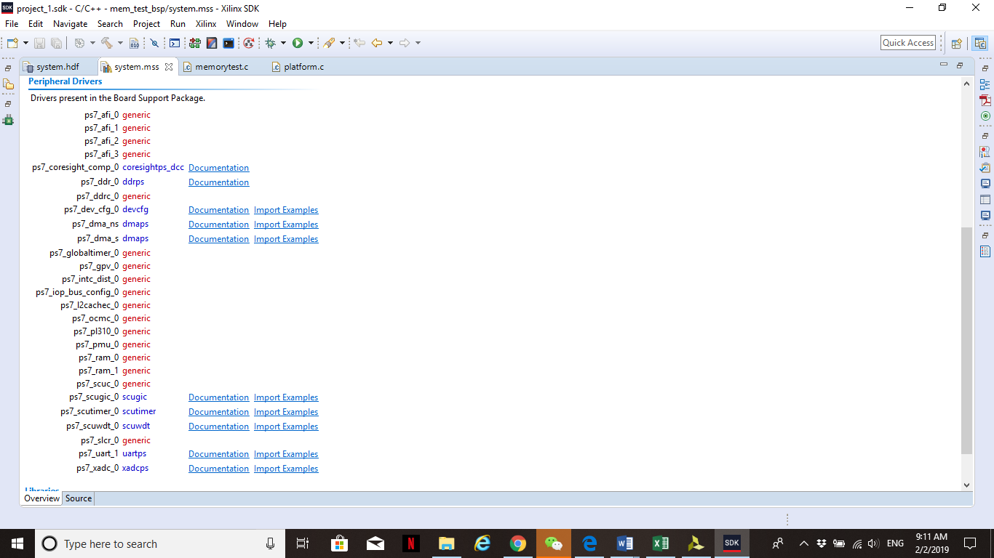

1. What is an .elf file? Is there an .elf file generated in this lab?

An [ELF](http://en.wikipedia.org/wiki/Executable_and_Linkable_Format) file is Executable Linkable Format file that is the executable code image that consists of executable code as well as a symbol look-ups and relocatable table (it can be loaded at any memory address by the kernel and automatically, all symbols used, are adjusted to the offset from that memory address where it was loaded into). **Note:** Only one ELF file is allowed per project.

Yes, there is a .elf file generated in Lab 1, the name of the file is: mem_test.elf.

1. Please provide a screenshot of your hardware block diagram and your embedded system output.

